Static Binding and Dynamic Binding



Connecting a method call to the method body is known as binding.

There are two types of binding

1. Static Binding (also known as Early Binding).
2. Dynamic Binding (also known as Late Binding).

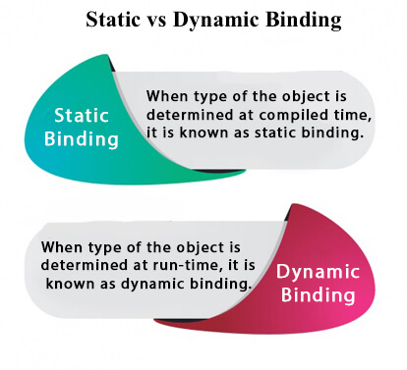

Understanding Type

Let's understand the type of instance.

1) variables have a type

Each variable has a type, it may be primitive and non-primitive.

1. **int** data=30;

Here data variable is a type of int.

2) References have a type

1. **class** Dog{
2. **public** **static** **void** main(String args[]){
3. Dog d1;//Here d1 is a type of Dog
4. }
5. }

3) Objects have a type

|  |
| --- |
| An object is an instance of particular java class,but it is also an instance of its superclass. |

1. **class** Animal{}
3. **class** Dog **extends** Animal{
4. **public** **static** **void** main(String args[]){
5. Dog d1=**new** Dog();
6. }
7. }

|  |
| --- |
| Here d1 is an instance of Dog class, but it is also an instance of Animal. |

static binding

When type of the object is determined at compiled time(by the compiler), it is known as static binding.

If there is any private, final or static method in a class, there is static binding.

Example of static binding

1. **class** Dog{
2. **private** **void** eat(){System.out.println("dog is eating...");}
4. **public** **static** **void** main(String args[]){
5. Dog d1=**new** Dog();
6. d1.eat();
7. }
8. }

Dynamic binding

When type of the object is determined at run-time, it is known as dynamic binding.

Example of dynamic binding

1. **class** Animal{
2. **void** eat(){System.out.println("animal is eating...");}
3. }
5. **class** Dog **extends** Animal{
6. **void** eat(){System.out.println("dog is eating...");}
8. **public** **static** **void** main(String args[]){
9. Animal a=**new** Dog();
10. a.eat();
11. }
12. }

**[Test it Now](http://www.javatpoint.com/opr/test.jsp?filename=Dog" \t "_blank)**

Output:dog is eating...

|  |
| --- |
| In the above example object type cannot be determined by the compiler, because the instance of Dog is also an instance of Animal.So compiler doesn't know its type, only its base type. |